 **Name___________________________**

**Maths Specialist – Investigation 2019**

**Circle Geometry- Part One**

**Extended investigation Part 1:** **Preparation activity**

**Using the Geometry Application on the ClassPad**

Tap  from the main menu to select the **Geometry application**.

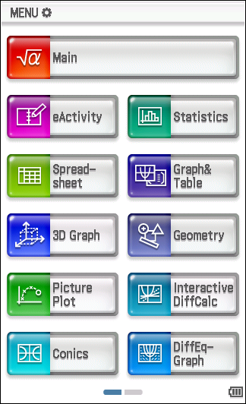 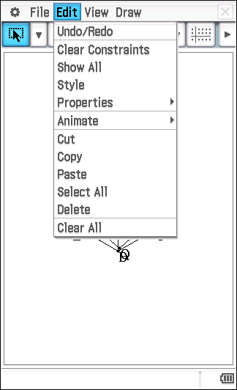 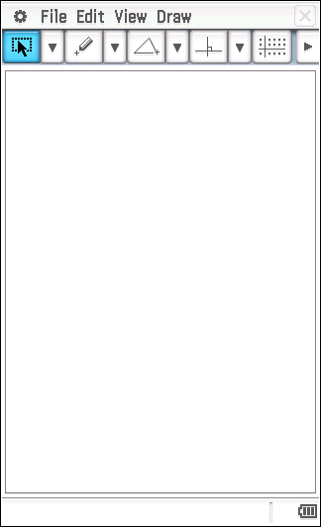

To clear the screen, tap **Edit**, tap **Clear all**.

Apply the following CAS settings for the Geometry application.

|  |  |
| --- | --- |
| Tap O  Tap **Geometry** **Format**  Set **Number Format** to **Fix 2**  Set **Measure** **Angle** to **Degree**  Set **Function Angle** to **Degree**  Set **Axes** to **Off**  Tap **Set** |  |

**Tools available in the Geometry application**

|  |  |
| --- | --- |
| By tapping on the down arrow, C, to the right of each of the drop down menus,  **[**C **P**C **p**C  a number of tools become available.  When a tool is referred to, the accompanying screen picture shows where the tool may be found. |  |

**The Measurement Box**

|  |  |
| --- | --- |
| Tap u to display the Measurement Box.  Tap w to return to the normal toolbar. | normal toolbar Measurement box |

The **Measurement Box** can be used to perform operations such as:

* viewing measurements such as length, angle size
* to specify a measurement, e.g. set a length to represent a measurement of 12 cm or an angle to be of size 48°
* to name a point, line segment, angle, …
* to determine whether a line is tangential to a circle
* to fix a line so that it is tangential to a circle

**NOTE:**

* To **deselect an object** (or objects), tap G and then tap anywhere in space within the Geometry window.
* To undo tap **Edit**, tap **Undo / Redo**.

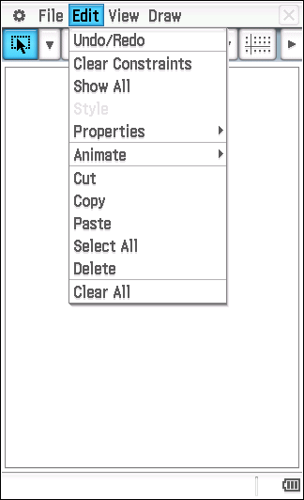

**Question 1**

Write a definition for each of following.

**Central Angle:**

**Chord:**

**Cyclic quadrilateral:**

**Diameter:**

**Radius:**

**Major/Minor Arc:**

**Major/Minor Segment:**

**Alternate Segment:**

**Major/Minor Sector:**

**Secant:**

**Semicircle:**

**Tangent:**

**Question 2**

|  |  |  |
| --- | --- | --- |
| Tap **m**.  Tap .  Tap **File**, tap **New** |  | |
| Draw a circle by tapping U and then tapping in two different places in the Geometry window.  Tap **View**, tap **Zoom to Fit**. | |  |
| Draw a line passing through centre A and point B by tapping w, then tap A, tap B.  Tap G. | |  |
| Select the circle and the line by tapping once on each of them.  Choose 7 to locate point D, the point of intersection of the circle and the line.  Draw diameter BD by tapping y, then tap B, tap D.  Tap G. | |  |
| To hide the line passing through D, A and B, tap on any part of this line that lies outside the circle, tap **Edit**, tap **Properties**, tap **Hide**.  Tap [ and mark a point, E, on the circle.  Tap y to draw two chords, BE and DE.  You have now drawn triangle BDE where E is a point on the circle and DE is a diameter of the circle centre A,  Tap G. | |  |
| Tap u to display the Measurement Box.  Measure the size of ∠BED by tapping once on BE and once on DE. The angle size of ∠BED will be displayed in the measurement box.  Tap on the angle size of ∠BED displayed in the Measurement Box and drag it into the Geometry window.  Name this angle BED by tapping u and using the 0 tab on the keyboard to type BED, press **=**, press **E**.  Hide the keyboard.  Tap in space. | |  |
| Observe the size of ∠BED as point E moves around the circle by using one of the two methods below:  Method One  Tap E, tap the circle.  Tap **Edit**, tap **Animate**, tap **Add Animation**.  Tap **Edit**, tap **Animate**, tap **Go (once)**.  Method Two  Tap E, tap E a second time and drag it around the circle.  To save this file, tap **File**, tap **Save** and name the file Qn_2. | |  |

(a) Why do you think ∠BED is referred to as the angle in the semicircle?

(b) What do you notice about the size of ∠BED as point E moves around the circle?

(c) Make a conjecture about the size of the angle in a semicircle.

**Conjecture:** The angle in a semicircle is …

**Question 3**

A proof of your conjecture about the angle in a semicircle has been started for you. Complete the proof. Remember that statements in the proof need to be justified.

**Angle in a Semicircle Theorem**

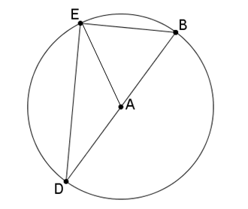

**Given**: Circle centre A, diameter BD. E is any point on the circle, ∠BED is an angle in the semicircle DBE.

**To Prove**:

**Extension to**

**the diagram:** Draw AE.

**Proof:**

**Question 4**

|  |  |  |  |  |
| --- | --- | --- | --- | --- |
| Tap **m**.  Tap .  Tap **File**, tap **New** | |  | | |
| Draw a circle by tapping U and then tapping in two different places in the Geometry window.  Tap **View**, tap **Zoom to Fit**. | | |  | |
| Tap [ and mark points, C and D, on the circle **as shown in the diagram.**  Tap y. Draw radii AC and AD; draw chords BC and BD.  Your diagram should show that ∠CBD is subtended at the circumference by arc CD in the same segment as ∠CAD (see diagram). Recall, points can be moved by tapping on the point once and then tapping a second time to drag to a new position. Don’t forget to tap in space to deselect before selecting a different item.  Tap G.  Tap u to display the Measurement Box. | | |  | |
| Display the size of ∠CBD by tapping BC and BD.  Tap on the size of ∠CBD and drag it into the Geometry window.  Name this angle CBD by tapping u and using the 0 tab on the keyboard to type CBD, press **=**. Press **E**.  Tap in space.  Display the size of ∠CAD by tapping AC and AD.  Tap on the size of ∠CAD and drag it into the Geometry window.  Name this angle CAD by tapping u and using the 0 tab on the keyboard to type CAD, press **=**. Press **E**.  Tap in space.  Hide the keyboard. | | |  | |
| Observe the size of angles ∠CAD and ∠CBD when points C and D respectively move on the circle.  Tap C. Tap C a second time and drag it around the circumference such that ∠CAD and ∠CBD both remain in the same segment.  Tap in space.  Tap D. Tap D a second time and drag it around the circumference such that ∠CAD and ∠CBD both remain in the same segment.  To save this file, tap **File**, tap **Save** and name the file Qn_4. | | |  | |

(a) By which arc are angles CBD and CAD both subtended?

(b) What do you notice about the size of the angle subtended at the centre of the circle, ∠CAD, and the size of the angle subtended at the circumference of the circle, ∠CBD?

(c) Make a conjecture about the size of the angle at the centre subtended by an arc of a circle and the size of the angle at the circumference subtended by the same arc.

**Conjecture:** The size of the angle at the centre subtended by an arc of the circle is …

**Question 5**

A proof of your conjecture about the central angle has been started for you. Complete the proof. Remember that statements in the proof need to be justified.

**Central Angle Theorem**

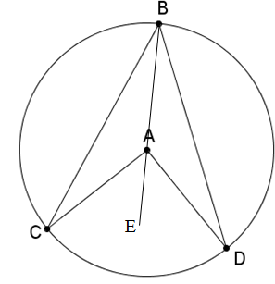

**Given**: Circle centre A. ∠CAD is the angle subtended by arc CD at the centre and ∠CBD is the angle subtended by arc CD at the circumference

**To Prove**:

**Extension to**

**the diagram**: Join BA and produce it to E.

**Proof: Statement Reason**

**Question 6**

Prove that two angles at the circumference subtended by the same arc are equal, i.e. .

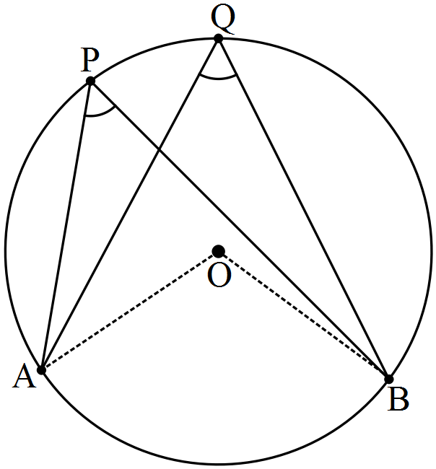

**Question 7**

Use the Geometry application to draw a circle centre A and radius AB. Mark points C and D on the circle as shown in the diagram below. Draw EC tangential to the circle at C by drawing a line through C. Tap u to display the Measurement Box. Tap on the line, tap on the circle. If **No** is displayed, tap b. EC is now tangential to the circle at C. Draw line segment EC and chords BD, CD and BC. ∠CBD is an angle in the alternate segment to ∠DCE.

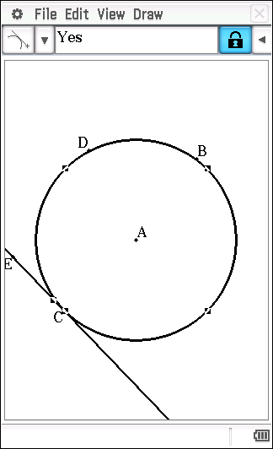 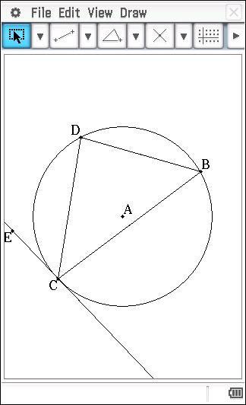

Note: it will be necessary to draw line segment EC prior to measuring the size of ∠DCE.

Save your file as Qn_6.

(a) Whilst maintaining the location of ∠CBD in the alternate segment to ∠DCE, move point D on the circle. What do you notice about the size of ∠CBD and the size of ∠DCE?

(b) Make a conjecture about the angles in the alternate segment.

**Conjecture:** An angle between a chord and a tangent is …

**Question 8**

Use the Geometry application to draw a circle centre A and radius AB. Position point C anywhere outside the circle and point D on the circle. Draw line segments CB and CD. Tap u to display the Measurement Box. Tap on CB, tap on the circle. If **No** is displayed, tap the tick, b. CB is now a tangent to the circle at B. In a similar manner, make CD a tangent to the circle at D.

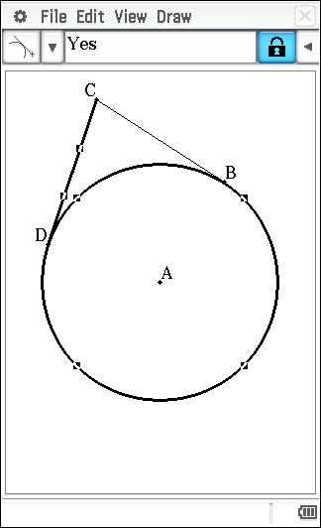

(a) What do you notice about the lengths of tangents CB and CD as you change the location of point C?

(b) Make a conjecture about the lengths of the tangents drawn from a point to a circle.

**Question 9**

Use the Geometry application to draw a circle centre A and radius AB**.** Use y to draw intersecting chords BC and DE. Select BC and DE, tap 7 to determine F, the point of intersection of chords BC and DE. Tap u to display the Measurement Box.

Display the length of chord BF by tapping on B and on F. Tap on the size of BF and drag it into the Geometry window. Label this chord length BF.

In a similar manner, display the length of chords CF, DF and EF.

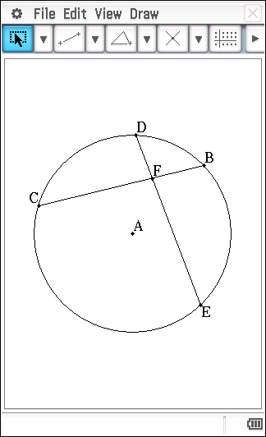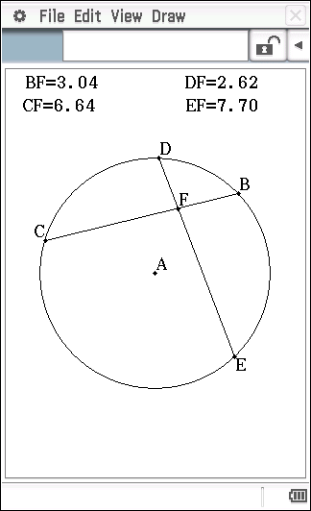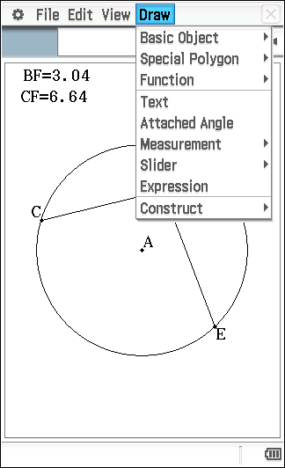

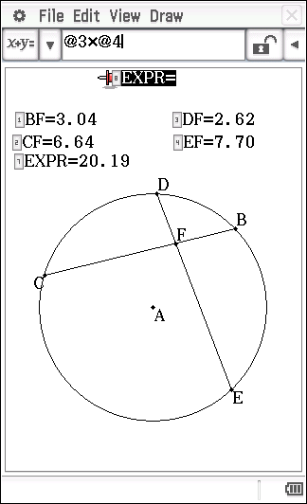

To calculate the product of BF and CF, tap Draw, tap Expression. Tap BF, press *, tap CF, press E. In a similar manner, display the product of DF and EF.

(a) What do you notice about BF x CF and DF x EF as you change the locations of C, D, E and F?

(b) Make a conjecture about the product of the lengths of the intervals on one chord and the product of the lengths of the intervals of an intersecting chord.

**Question 10**

(a) AB, AC and BC are tangents; AB = 15 cm; BC = 17 cm; BP = 9 cm. Find AC.

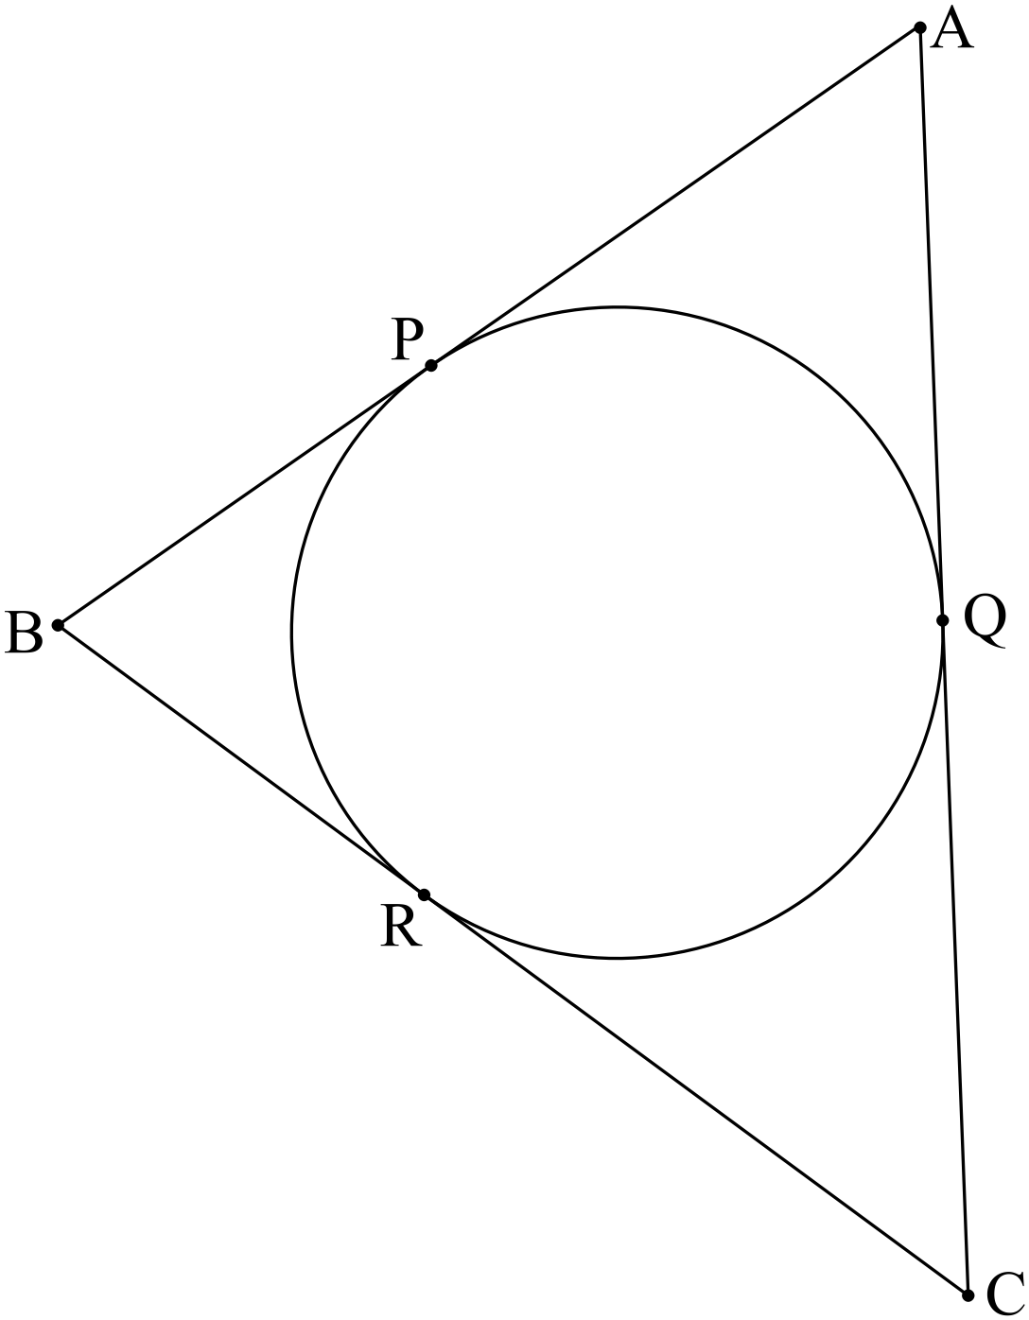

(b) AB and AC are tangents; . Find the size of 

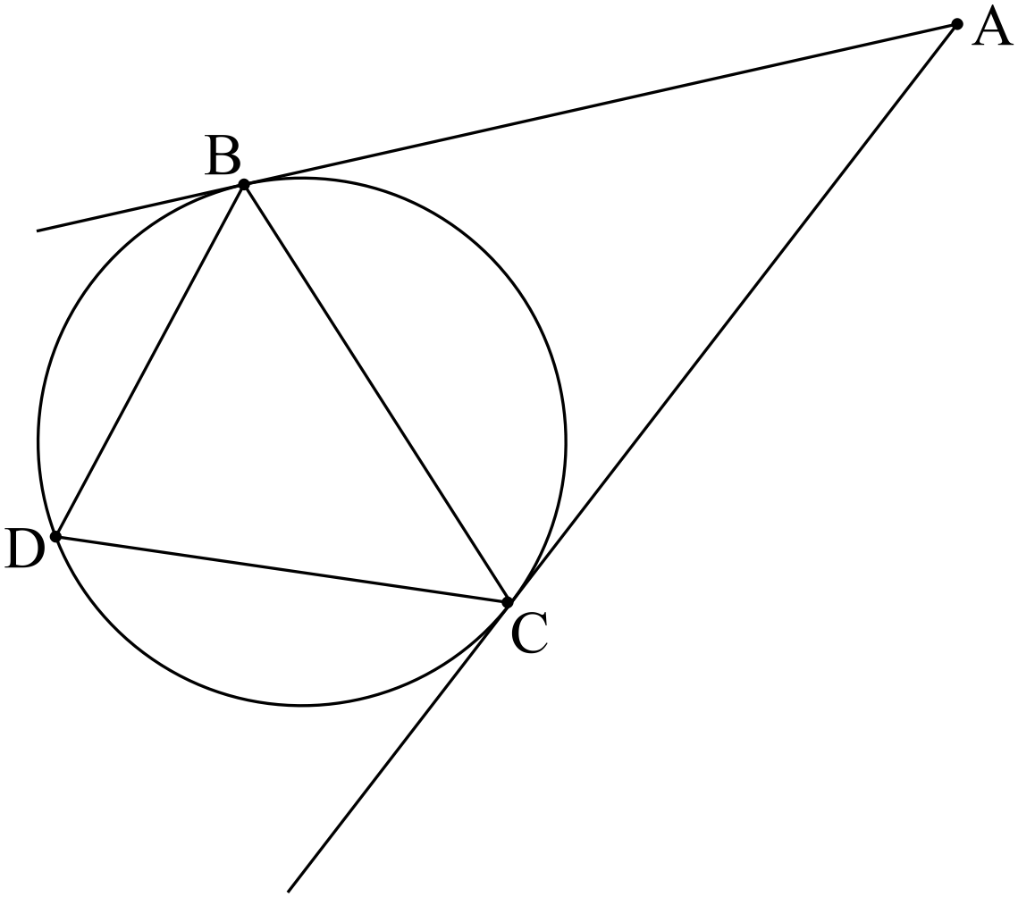

(c) PE is a tangent; AD is parallel to PC; . Find the size  and .

